Project Initialisation and Planning Phase

Date | 5th July 2024
Team ID | 739719
Project Name | Garment Workers Productivity Predictions
Maximum Marks | 3 Marks

Define Problem Statements (Customer Problem Statement Template):
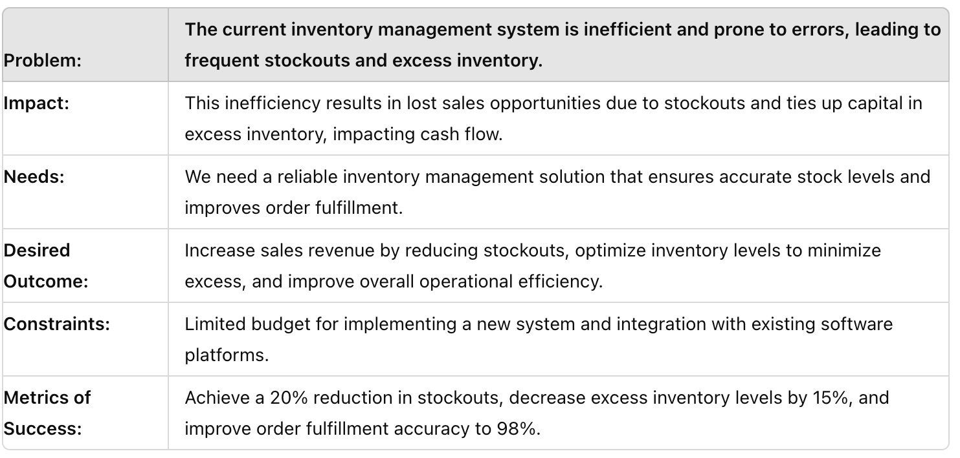
To develop a predictive model that accurately forecasts the productivity of garment workers based on various factors, aiming to optimise manufacturing efficiency and resource utilisation."
Reference: https://miro.com/templates/customer-problem-statement/
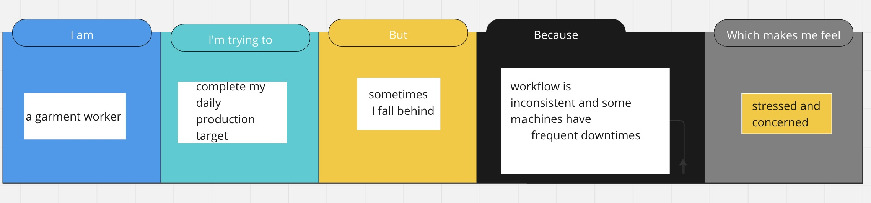
Example:

Problem  Statement (PS) | I am  (Customer) | I’m trying to | But | Because | Which makes me feel
PS-1 | A garment factory manager | Accurately predict worker productivity | The current prediction model is not precise | It doesn’t account for all variables like worker skill levels and machine downtime | Frustrated and unable to optimise  Production schedule
PS-2 | An operations manager | Improve overall efficiency in the factory | Productivity  Predictions are often delayed | Data collection and processing take too long | Concerned about  meeting production  targets and deadlines

